Super Tic-Tac-Toe
Multiplayer Platform

Milestone 1 — Database Design & ERD
Version Control Document | April 2026

MILESTONE | DATE | VERSION | REMARKS
ERD + SCHEMA | 24 / 4 / 2026 | V1.0 | Initial release

GROUP MEMBERS
Muhammad Hammad Shakeel · Sikandar Khaleel · Aurshia Mudassar

1. System Overview

Super Tic-Tac-Toe is a competitive online multiplayer platform that extends classic Tic-Tac-Toe into a skill-based game with ranked play, tournaments, social features, and real-time messaging. It supports multiple board variants, community groups, and an ELO-based rating system with full game history and replay capability.

1.1 Core Modules
Game Engine — Manages game types (GAMETYPE), game instances (GAME), move storage, real-time status, and ELO outcome recording (GAME_HISTORY). Every match is persisted with a full CSV move sequence for replay and analytics.
Tournament System — Organises competitive brackets (STRUCTURE), events (TOURNAMENT), and participants (PARTICIPANT). Supports single-elimination, round-robin, Swiss, and double-elimination formats with seeding and prize tracking.
Social Layer — Handles bilateral friend connections (FRIENDS), named player communities (GROUP), and role-aware group membership (GROUP_LIST). All social features operate in parallel with gameplay.
Player Profile — Stores identity, hashed credentials, current and peak ELO, win/loss/draw record, country, and full game history. The PLAYER table is the FK target for nearly every other table in the schema.
Messaging — Direct message threads (CHAT) between any two players, with individual messages (MESSAGE) that support text and media attachments, read receipts, and inbox sorting via denormalised last_message_at.

1.2 Application Workflow
The diagram below maps the complete user journey from registration through ranked play, tournament entry, social interaction, and messaging. Coloured lanes represent each module; arrows show control flow and data writes.

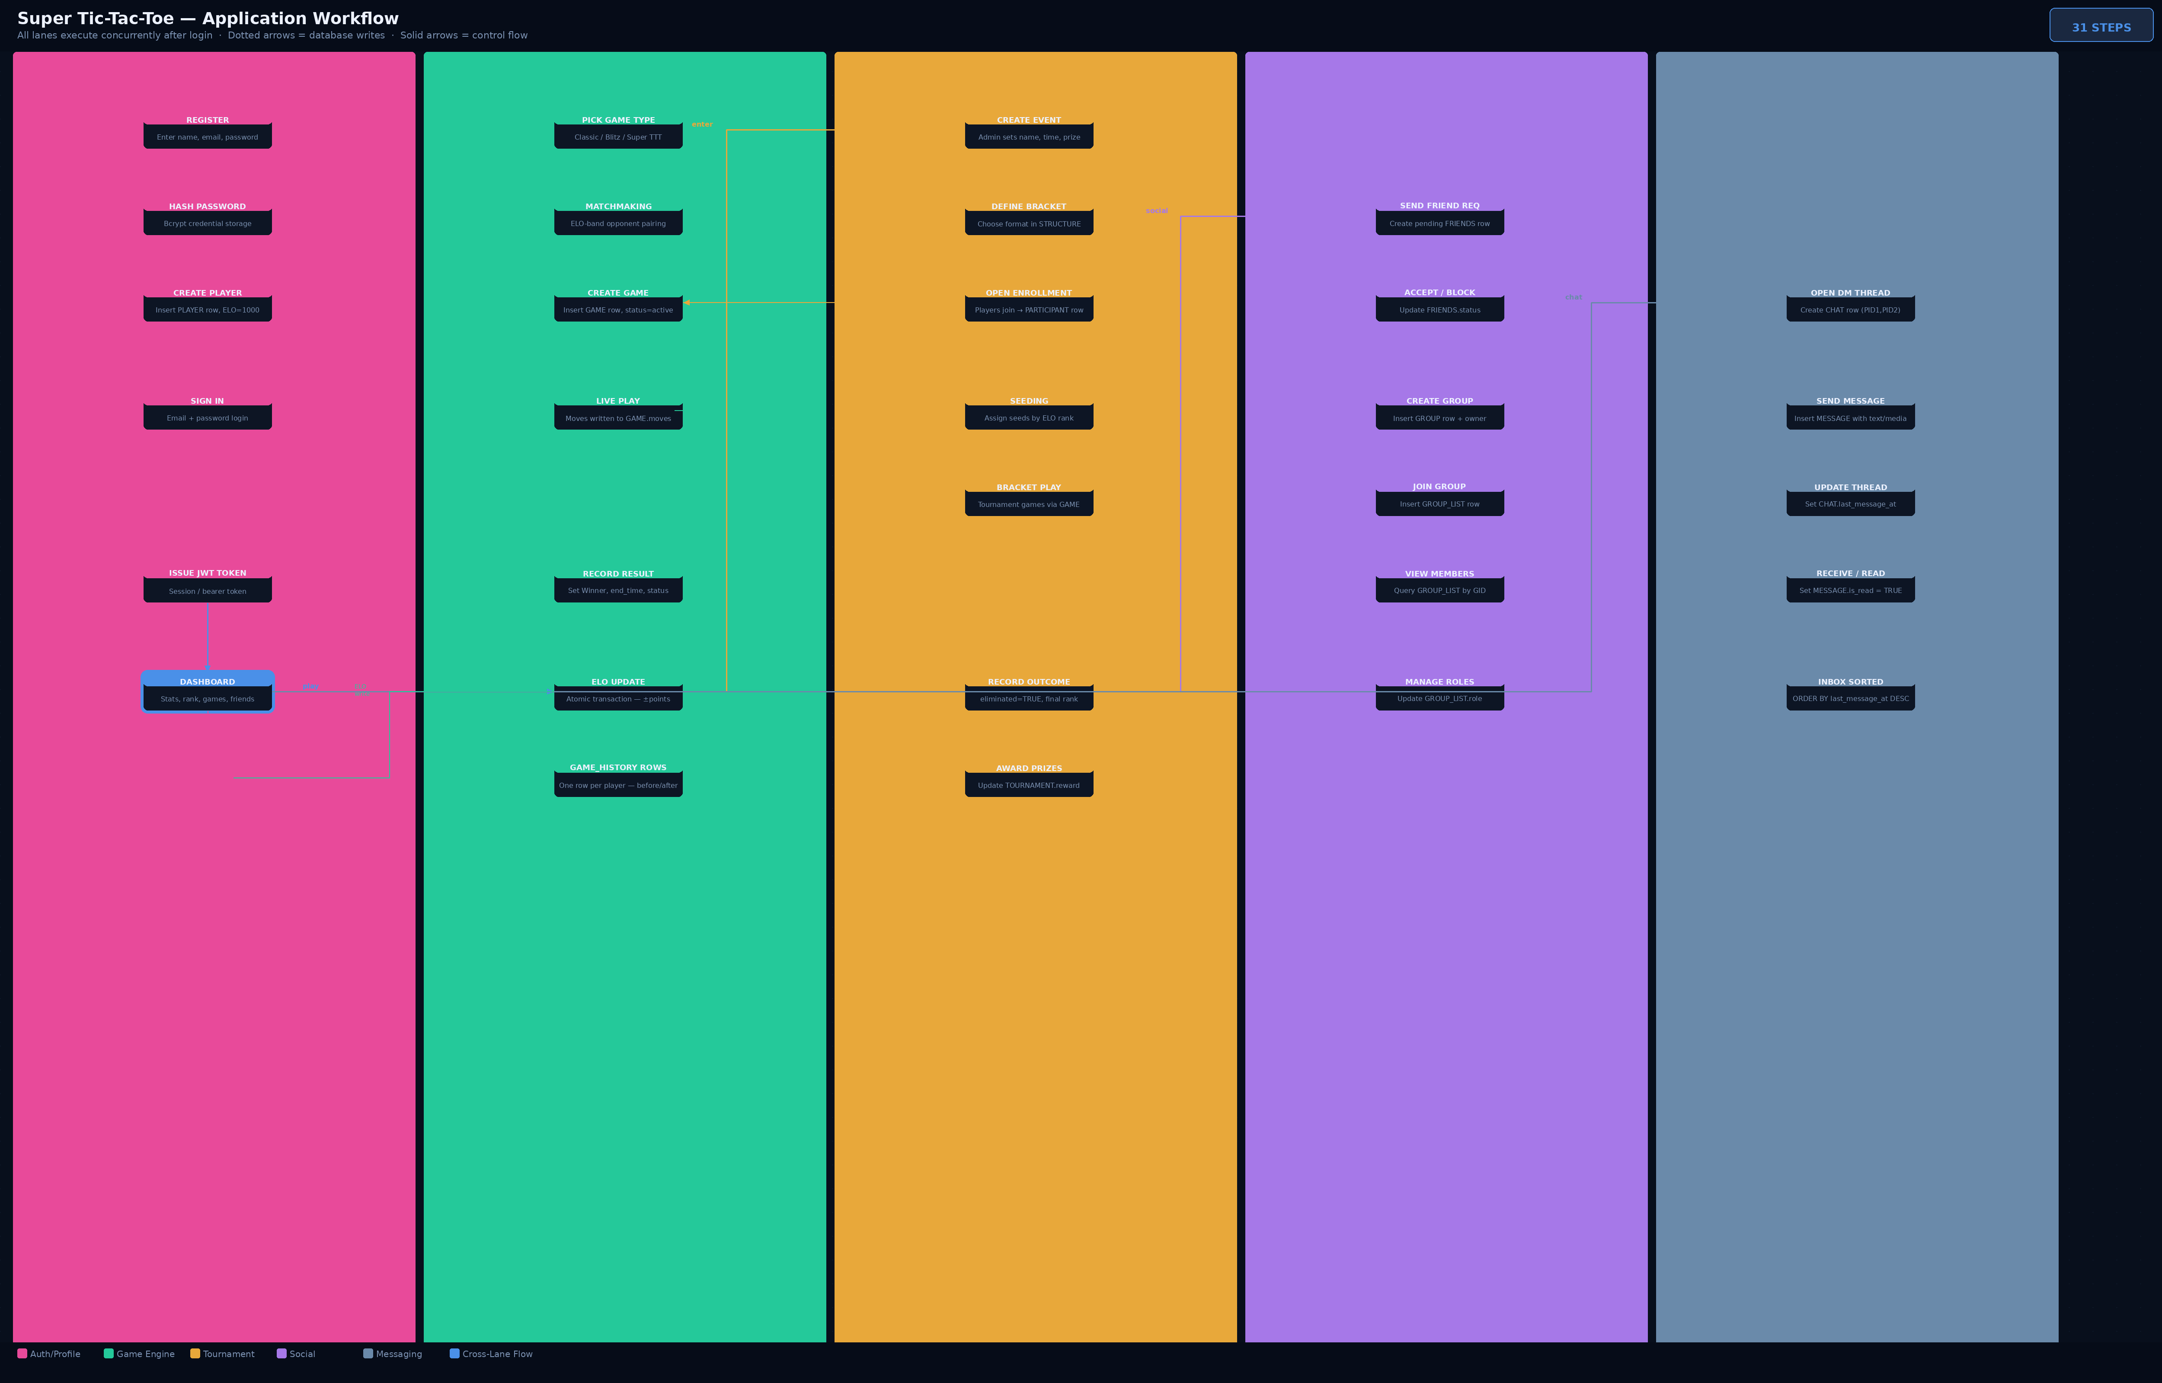

Figure 1 — Application Workflow Diagram: 5 lanes, 31 steps from register to tournament close

Workflow Walkthrough
Step 1–3 (Auth): New user submits email and password. Password is hashed with Bcrypt and a PLAYER row is created with default ELO 1000. A JWT session token is issued.
Steps 4–6 (Sign In): Returning user authenticates; JWT is issued and the dashboard is loaded showing stats, friends, active games, and open tournaments.
Steps 7–13 (Game Engine): Player selects a game type and enters matchmaking. An ELO-band opponent is found; a GAME row is created (status=active). Moves are written to GAME.moves in real time. On game end, the winner is recorded, ELO is updated in an atomic transaction, and two GAME_HISTORY rows are committed (one per player).
Steps 14–20 (Tournament): Admin creates a TOURNAMENT and links a STRUCTURE bracket. Players enroll (PARTICIPANT rows). Seeds are assigned by ELO. Tournament games run through the Game Engine. Eliminated players are flagged; final ranks and prizes are recorded on tournament close.
Steps 21–26 (Social): At any time, players can send friend requests (FRIENDS row with status=pending), accept/block them, create or join groups (GROUP + GROUP_LIST rows), and manage member roles.
Steps 27–31 (Messaging): Opening a DM creates a CHAT row. Each sent message creates a MESSAGE row and updates CHAT.last_message_at for inbox sorting. Recipients set is_read=TRUE on open.

2. Entity-Relationship Diagrams

This section presents the schema visually. The full reference diagram below shows all 12 tables with every attribute, data type, constraint badge (PK, FK, NN, DEF, UQ), and relationship arrow. Refer to Section 3 for the full prose description of each table.

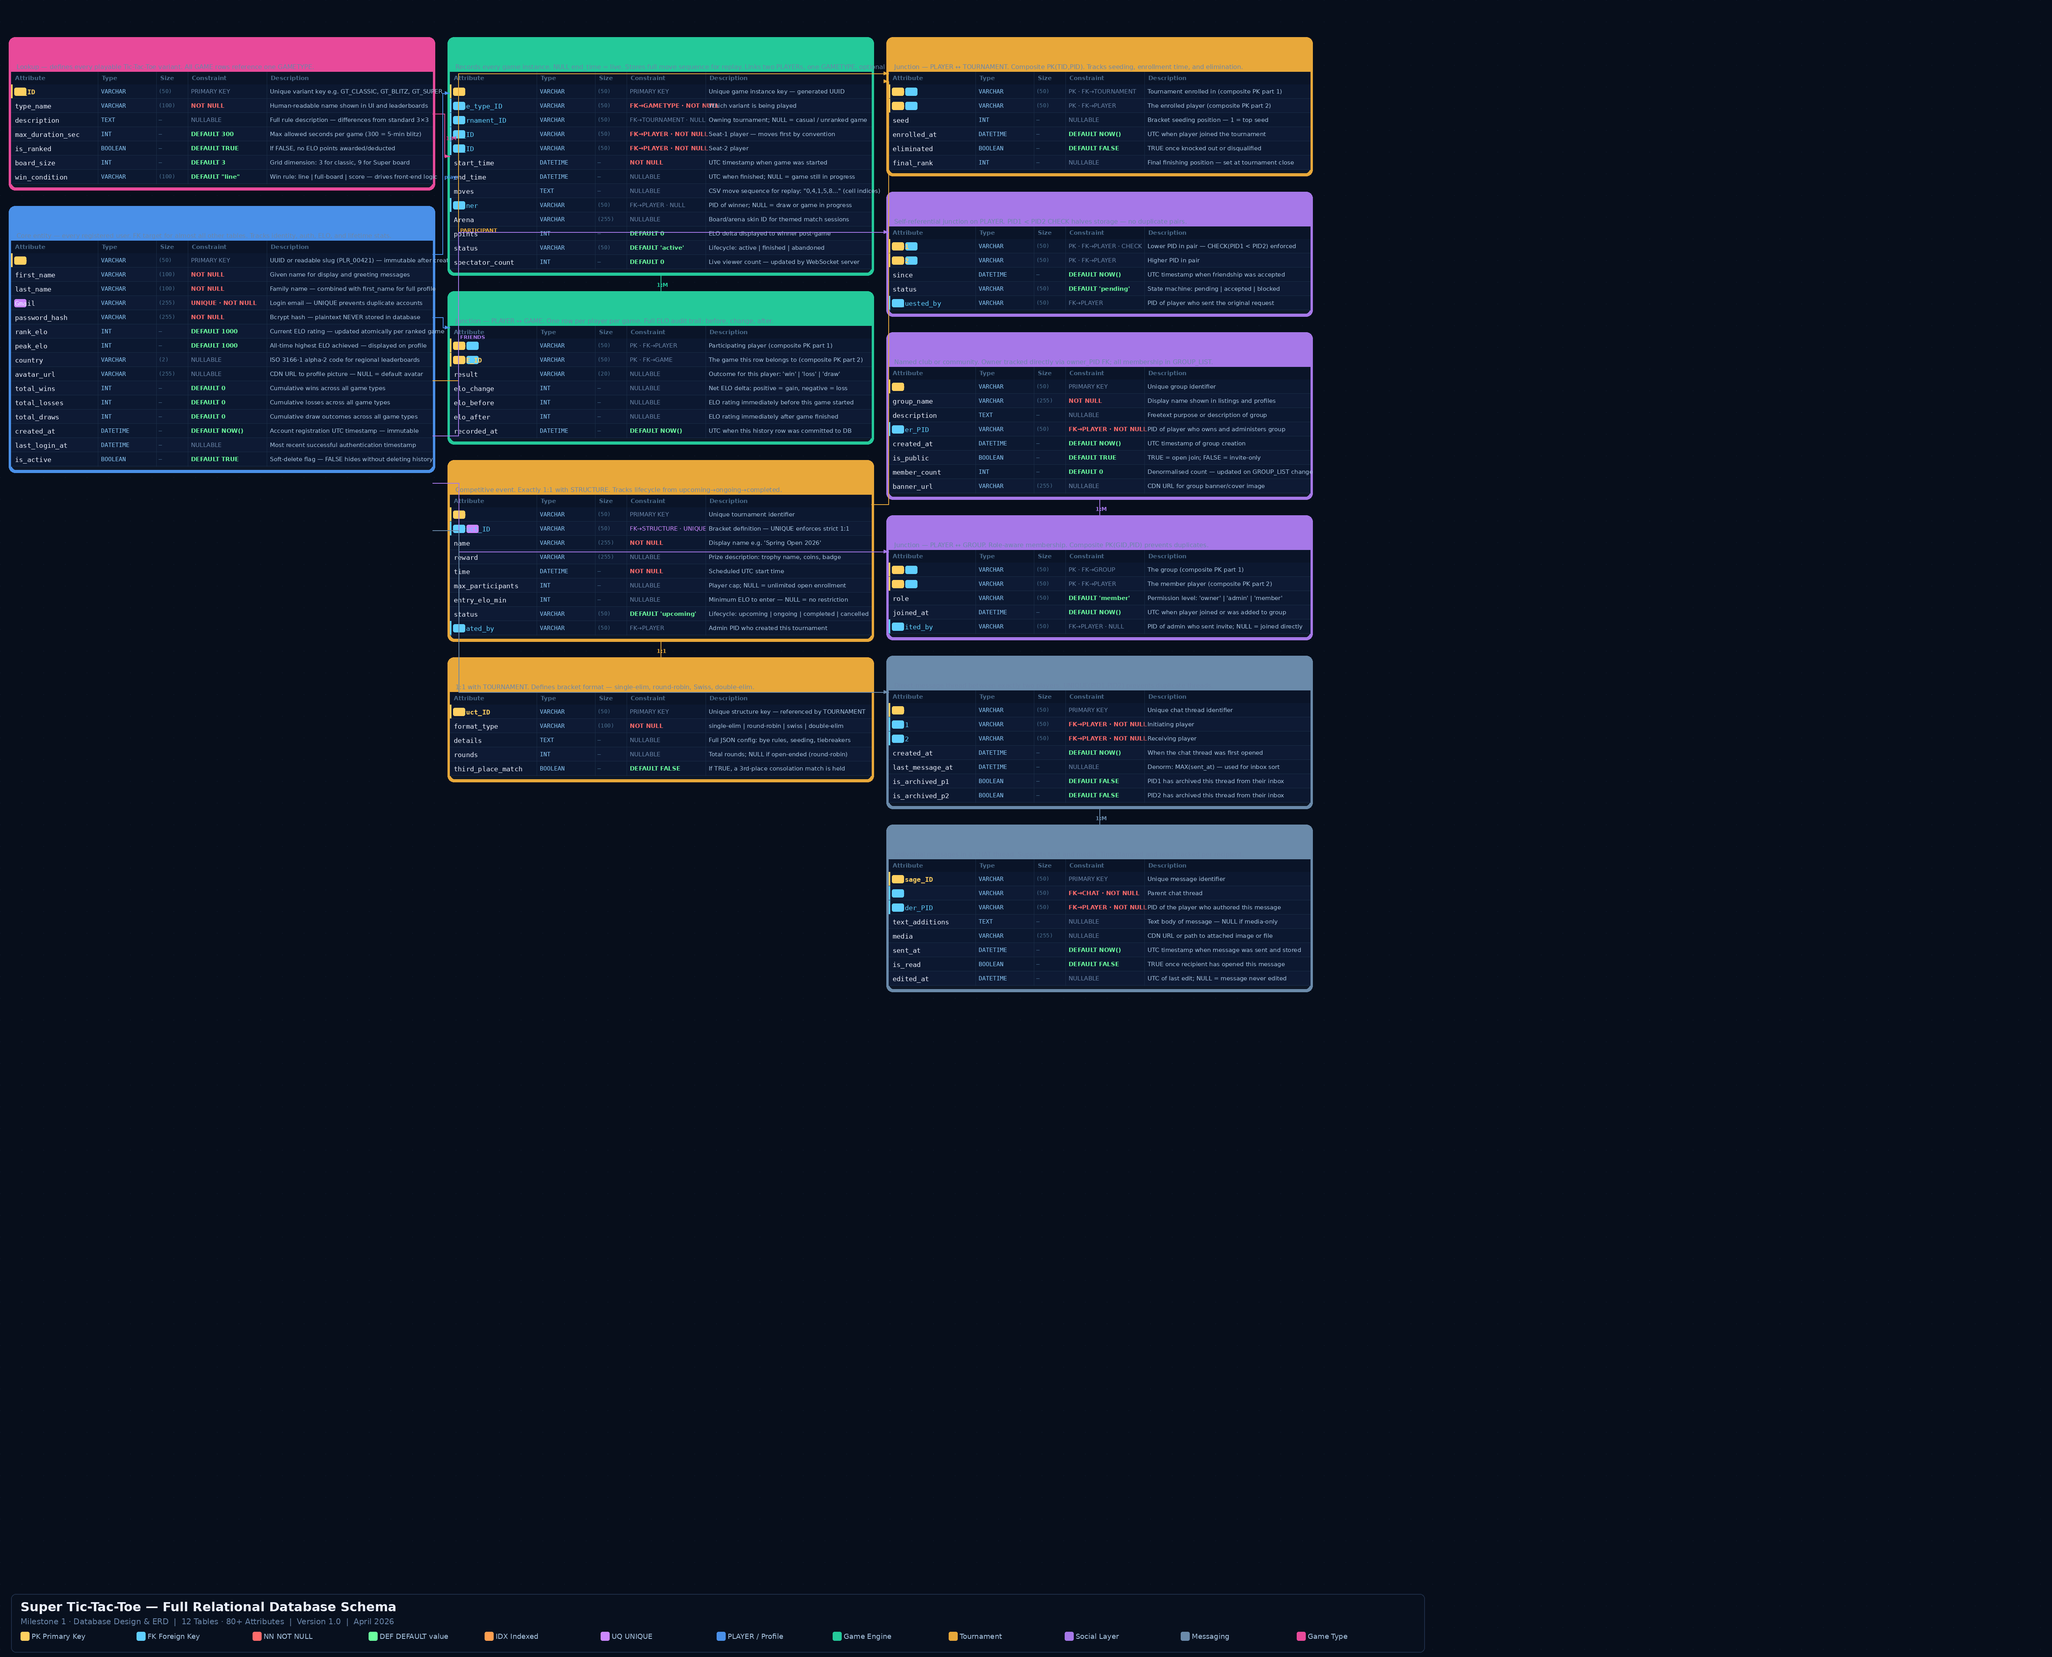

Figure 2 — Full Relational Schema: 12 tables, 80+ attributes, PK/FK/NN/DEF badges, relationship arrows

i | Reading the Schema Diagram  Gold left-border = Primary Key column. Blue left-border = Foreign Key. Red constraint text = NOT NULL. Green = DEFAULT value. Purple = UNIQUE constraint. Dashed arrows = database writes; solid arrows = control flow. Relationship cardinality (1:M, M:N, 1:1) is labelled on each arrow.

3. Relational Database Schema

This section describes every table: its purpose, design rationale, all attributes with data types, sizes, and constraints, and its relationships to other tables. Tables are grouped into the four logical modules they belong to. Attribute count: 80+ across 12 tables.

i | Schema Design Principles  All M:N relationships use junction tables with composite PKs. ELO updates run inside atomic transactions. All FKs should use ON DELETE CASCADE for referential integrity. VARCHAR IDs allow human-readable slugs (PLR_00421, GT_CLASSIC) while remaining sortable and indexable. Soft-delete on PLAYER (is_active) preserves all historical data.

3.1 | GAMETYPE LOOKUP

Lookup table that defines every playable variant of Tic-Tac-Toe on the platform. Acts as the central game-type registry. All GAME rows reference one GAMETYPE, keeping variant rules fully normalised so adding a new mode (e.g. Timed, 5x5) only requires one new row.

i | Design Note  is_ranked allows practice modes to coexist with competitive variants without affecting ELO. board_size drives the front-end grid renderer. win_condition allows different winning rules (line, full-board, score) without schema changes.

Attribute | Type | Size | Constraint | Description
[PK] GT_ID | VARCHAR | (50) | PRIMARY KEY | Unique variant key (GT_CLASSIC, GT_BLITZ, GT_SUPER, GT_TIMED)
type_name | VARCHAR | (100) | NOT NULL | Human-readable name shown in UI: 'Classic 3x3', 'Blitz', 'Super'
description | TEXT | --- | NULLABLE | Full rule description and key differences from standard 3x3
max_duration_sec | INT | --- | DEFAULT 300 | Max allowed seconds per game. 300 = 5-min blitz; NULL = untimed
is_ranked | BOOLEAN | --- | DEFAULT TRUE | If FALSE, no ELO points awarded or deducted for this variant
board_size | INT | --- | DEFAULT 3 | Grid dimension: 3 for classic 3x3, 9 for Super Tic-Tac-Toe
win_condition | VARCHAR | (100) | DEFAULT "line" | Winning rule: line | full-board | score. Drives front-end logic

Relationships
- One GAMETYPE may be referenced by many GAME instances (1:M via GAME.Game_type_ID)

3.2 | PLAYER CORE

Central entity representing every registered user on the platform. Almost every other table references PLAYER via FK. Stores identity, hashed credentials, current and all-time peak ELO, aggregated win/loss/draw statistics, and account metadata including soft-delete support.

i | Design Note  rank_elo must be updated atomically inside a database transaction after every ranked game to prevent concurrent-write corruption. is_active enables soft-delete so game history, messages, and leaderboard entries remain valid after account deactivation. peak_elo is set whenever rank_elo exceeds it, enabling "all-time best" profile badges.

Attribute | Type | Size | Constraint | Description
[PK] PID | VARCHAR | (50) | PRIMARY KEY | UUID or readable slug (PLR_00421) — immutable after creation
first_name | VARCHAR | (100) | NOT NULL | Given name for display on profile and greeting messages
last_name | VARCHAR | (100) | NOT NULL | Family name — combined with first_name for full name display
[UQ] Gmail | VARCHAR | (255) | UNIQUE, NOT NULL | Login email — UNIQUE constraint prevents duplicate accounts
password_hash | VARCHAR | (255) | NOT NULL | Bcrypt-hashed credential — plaintext is NEVER stored
rank_elo | INT | --- | DEFAULT 1000 | Current ELO rating. Starts at 1000. Updated atomically per game
peak_elo | INT | --- | DEFAULT 1000 | All-time highest ELO achieved — displayed on profile badge
country | VARCHAR | (2) | NULLABLE | ISO 3166-1 alpha-2 code (e.g. PK, US) for regional leaderboards
avatar_url | VARCHAR | (255) | NULLABLE | CDN URL to profile picture — NULL = default placeholder avatar
total_wins | INT | --- | DEFAULT 0 | Cumulative wins across all game types and variants
total_losses | INT | --- | DEFAULT 0 | Cumulative losses across all game types and variants
total_draws | INT | --- | DEFAULT 0 | Cumulative draws — tracked separately from wins/losses
created_at | DATETIME | --- | DEFAULT NOW() | Account registration UTC timestamp — immutable after creation
last_login_at | DATETIME | --- | NULLABLE | Most recent successful authentication timestamp for activity tracking
is_active | BOOLEAN | --- | DEFAULT TRUE | Soft-delete flag. FALSE = deactivated, data preserved

Relationships
- PLAYER -> GAME via GAME_HISTORY (M:N junction — full game and ELO history)
- PLAYER -> TOURNAMENT via PARTICIPANT (M:N junction — enrollment and seeding)
- PLAYER -> PLAYER via FRIENDS (self-referential M:N — bilateral friendships)
- PLAYER -> GROUP via GROUP_LIST (M:N junction — role-aware membership)
- PLAYER -> CHAT as PID1 or PID2 (1:M — DM thread initiator or recipient)
- PLAYER -> GROUP as owner_PID (1:M — group owner direct FK for fast lookup)

3.3 | GAME CORE

Records every game instance played on the platform. Links two players (P1_ID, P2_ID) to a game type and optionally to a tournament. Stores the complete move sequence as CSV-encoded cell indices for replay and analytics. A NULL end_time indicates the game is currently live. spectator_count is updated in real time by the WebSocket server.

i | Design Note  GAME.moves stores the full sequence as CSV text (e.g. '0,4,1,5,8') to keep the schema simple and the replay feature functional. A future MOVE table could be added for per-move timing analytics without migrating this data. The Arena field supports themed board skins without altering game logic.

Attribute | Type | Size | Constraint | Description
[PK] ID | VARCHAR | (50) | PRIMARY KEY | Unique game instance key — generated UUID per match
[FK] Game_type_ID | VARCHAR | (50) | FK->GAMETYPE, NOT NULL | Which variant is being played in this instance
[FK] Tournament_ID | VARCHAR | (50) | FK->TOURNAMENT, NULL | Owning tournament; NULL = casual or unranked game
[FK] P1_ID | VARCHAR | (50) | FK->PLAYER, NOT NULL | Seat-1 player — moves first by convention
[FK] P2_ID | VARCHAR | (50) | FK->PLAYER, NOT NULL | Seat-2 player
start_time | DATETIME | --- | NOT NULL | UTC timestamp when game was started and GAME row inserted
end_time | DATETIME | --- | NULLABLE | UTC when finished; NULL = game still in progress (live)
moves | TEXT | --- | NULLABLE | CSV move sequence for replay: '0,4,1,5,8' = cell indices
[FK] Winner | VARCHAR | (50) | FK->PLAYER, NULL | PID of winner; NULL = draw or game in progress
Arena | VARCHAR | (255) | NULLABLE | Board skin identifier for themed match sessions
points | INT | --- | DEFAULT 0 | ELO delta awarded to winner — shown in post-game summary
status | VARCHAR | (50) | DEFAULT 'active' | Lifecycle: 'active' | 'finished' | 'abandoned'
spectator_count | INT | --- | DEFAULT 0 | Live viewer count — updated by WebSocket server in real time

Relationships
- GAME -> GAMETYPE (M:1 — each game instance has one variant)
- GAME -> TOURNAMENT (M:1 — optional; NULL for casual games)
- GAME -> PLAYER x3 (P1_ID, P2_ID, Winner — all FK to PLAYER)
- GAME <- GAME_HISTORY (1:M — each game generates two history rows, one per player)

3.4 | GAME_HISTORY JUNCTION

Junction table resolving the M:N relationship between PLAYER and GAME. Each row records one player participation in one game, the outcome (win/loss/draw), and the full ELO audit trail — rating before the game, the change amount, and rating after. Composite PK (PID, GAME_ID) guarantees no duplicate entries.

i | Design Note  Storing elo_before + elo_change + elo_after enables complete rating history reconstruction without replaying all prior games. This makes cheating audits, rating rollbacks, and "ELO over time" charts straightforward. recorded_at captures the exact commit time for timeline accuracy.

Attribute | Type | Size | Constraint | Description
[PK] [FK] PID | VARCHAR | (50) | PK, FK->PLAYER | The participating player (composite PK part 1)
[PK] [FK] GAME_ID | VARCHAR | (50) | PK, FK->GAME | The game this row belongs to (composite PK part 2)
result | VARCHAR | (20) | NULLABLE | Outcome for this player: 'win' | 'loss' | 'draw'
elo_change | INT | --- | NULLABLE | Net ELO delta: positive = gain, negative = loss from this game
elo_before | INT | --- | NULLABLE | Player's ELO rating immediately before this game started
elo_after | INT | --- | NULLABLE | Player's ELO rating immediately after game result was committed
recorded_at | DATETIME | --- | DEFAULT NOW() | UTC timestamp when this history row was committed to the database

Relationships
- GAME_HISTORY -> PLAYER (M:1 — many history rows reference one player)
- GAME_HISTORY -> GAME (M:1 — many history rows reference one game instance)

3.5 | TOURNAMENT CORE

Represents a competitive event containing an ordered series of game instances. Each tournament is linked 1:1 to a STRUCTURE bracket (enforced by UNIQUE on struct_ID). Tracks lifecycle from upcoming to ongoing to completed, with an optional player cap, minimum ELO entry requirement, and prize field.

i | Design Note  max_participants is nullable to support open-enrollment events. entry_elo_min restricts who can enter, enabling tiered competition (Bronze/Silver/Gold). The UNIQUE constraint on struct_ID enforces the 1:1 relationship: a bracket cannot be shared across multiple tournaments.

Attribute | Type | Size | Constraint | Description
[PK] TID | VARCHAR | (50) | PRIMARY KEY | Unique tournament identifier
[FK] [UQ] struct_ID | VARCHAR | (50) | FK->STRUCTURE, UNIQUE | Bracket definition — UNIQUE enforces strict 1:1 with STRUCTURE
name | VARCHAR | (255) | NOT NULL | Display name e.g. 'Spring Open 2026', 'Friday Blitz Cup'
reward | VARCHAR | (255) | NULLABLE | Prize description: trophy name, coins, title badge, gift cards
time | DATETIME | --- | NOT NULL | Scheduled UTC start time of the tournament
max_participants | INT | --- | NULLABLE | Player cap; NULL = unlimited / open enrollment
entry_elo_min | INT | --- | NULLABLE | Minimum ELO to enter — NULL = no restriction (open to all)
status | VARCHAR | (50) | DEFAULT 'upcoming' | Lifecycle: 'upcoming' | 'ongoing' | 'completed' | 'cancelled'
[FK] created_by | VARCHAR | (50) | FK->PLAYER | PID of admin player who created this tournament

Relationships
- TOURNAMENT -> STRUCTURE (1:1 — each tournament has exactly one bracket format)
- TOURNAMENT <- GAME (1:M — tournament contains many game instances)
- TOURNAMENT <- PARTICIPANT (1:M via junction — many players enrolled per event)

3.6 | STRUCTURE LOOKUP

Defines the bracket or competition format of a tournament. Kept as a separate table to fully normalise format definitions and allow them to be reused as named presets across multiple tournaments. Supports single-elimination, round-robin, Swiss, and double-elimination.

i | Design Note  The details field holds a full JSON config for custom rules: bye handling, tiebreaker logic, seeding algorithms, and round counts. Separating format from tournament data means 'Swiss 6-round open bracket' can be a named, reusable preset rather than duplicated config.

Attribute | Type | Size | Constraint | Description
[PK] struct_ID | VARCHAR | (50) | PRIMARY KEY | Unique structure identifier — referenced by TOURNAMENT.struct_ID
format_type | VARCHAR | (100) | NOT NULL | Format name: 'single-elim' | 'round-robin' | 'swiss' | 'double-elim'
details | TEXT | --- | NULLABLE | Full JSON config — bye rules, tiebreakers, seeding algorithm
rounds | INT | --- | NULLABLE | Total rounds; NULL if format is open-ended (e.g. round-robin)
third_place_match | BOOLEAN | --- | DEFAULT FALSE | If TRUE, a 3rd-place consolation match is scheduled

Relationships
- STRUCTURE <- TOURNAMENT (1:1 — one bracket definition per tournament)

3.7 | PARTICIPANT JUNCTION

Junction table resolving the M:N relationship between PLAYER and TOURNAMENT. Each row tracks one player enrollment in one tournament: their seeding position, when they enrolled, whether they have been eliminated, and their final finishing rank. Composite PK (TID, PID) prevents duplicate registrations.

i | Design Note  final_rank is set at tournament close for leaderboard and prize distribution. seed is assigned by an ELO-based algorithm before the bracket begins. eliminated=TRUE is set whenever a player loses in single-elimination or is disqualified — the field drives bracket rendering on the front end.

Attribute | Type | Size | Constraint | Description
[PK] [FK] TID | VARCHAR | (50) | PK, FK->TOURNAMENT | Tournament the player is enrolled in (composite PK part 1)
[PK] [FK] PID | VARCHAR | (50) | PK, FK->PLAYER | The enrolled player (composite PK part 2)
seed | INT | --- | NULLABLE | Bracket seed position — 1 = top seed; assigned before play starts
enrolled_at | DATETIME | --- | DEFAULT NOW() | UTC timestamp when the player enrolled or was registered
eliminated | BOOLEAN | --- | DEFAULT FALSE | TRUE once the player is knocked out or disqualified from bracket
final_rank | INT | --- | NULLABLE | Final finishing position — set at tournament close for prizes

Relationships
- PARTICIPANT -> TOURNAMENT (M:1 — many players per tournament)
- PARTICIPANT -> PLAYER (M:1 — one player per enrollment row)

3.8 | FRIENDS JUNCTION

Self-referential junction table on PLAYER modelling bilateral friendships. The PID1 < PID2 convention (enforced via a CHECK constraint) ensures each friendship pair is stored exactly once, halving storage and eliminating duplicate-pair query bugs. Supports a three-state request flow: pending, accepted, blocked.

i | Design Note  The CHECK constraint (PID1 < PID2) is the critical design decision. Without it, both (Alice, Bob) and (Bob, Alice) would be valid rows, doubling storage and requiring UNION queries to retrieve a player's friends. requested_by identifies who sent the original request for display in the notification UI.

Attribute | Type | Size | Constraint | Description
[PK] [FK] PID1 | VARCHAR | (50) | PK, FK->PLAYER, CHECK | Lower PID by convention — CHECK(PID1 < PID2) enforced at DB level
[PK] [FK] PID2 | VARCHAR | (50) | PK, FK->PLAYER | Higher PID by convention — second partner in the friendship pair
since | DATETIME | --- | DEFAULT NOW() | UTC timestamp when the friendship was accepted and activated
status | VARCHAR | (50) | DEFAULT 'pending' | State: 'pending' (waiting for accept) | 'accepted' | 'blocked'
[FK] requested_by | VARCHAR | (50) | FK->PLAYER | PID of the player who initiated the original friend request

Relationships
- FRIENDS -> PLAYER x2 (PID1 and PID2 both FK to PLAYER — self-referential M:N)

3.9 | GROUP CORE

Represents a named club, community, or team within the platform. Players can belong to many groups and each group can have many members, managed via the GROUP_LIST junction. The group owner is tracked directly in GROUP.owner_PID for fast ownership queries, separate from the membership junction table.

i | Design Note  owner_PID gives a direct FK for fast owner lookup without scanning GROUP_LIST. member_count is a denormalised counter updated whenever GROUP_LIST changes — avoids COUNT(*) subqueries on every group card render. is_public controls whether players can self-join or must be invited by an admin.

Attribute | Type | Size | Constraint | Description
[PK] GID | VARCHAR | (50) | PRIMARY KEY | Unique group identifier
group_name | VARCHAR | (255) | NOT NULL | Display name shown in group listings, search results, and profiles
description | TEXT | --- | NULLABLE | Freetext purpose, rules, or description of the group
[FK] owner_PID | VARCHAR | (50) | FK->PLAYER, NOT NULL | PID of player who created and owns this group
created_at | DATETIME | --- | DEFAULT NOW() | UTC timestamp of group creation — shown on group profile
is_public | BOOLEAN | --- | DEFAULT TRUE | TRUE = any player can join freely; FALSE = invite-only
member_count | INT | --- | DEFAULT 0 | Denormalised count — updated via trigger on GROUP_LIST insert/delete
banner_url | VARCHAR | (255) | NULLABLE | CDN URL for group banner or cover image displayed at top of group page

Relationships
- GROUP <- GROUP_LIST (1:M — group has many member rows)
- GROUP -> PLAYER via owner_PID (M:1 — one owner per group)

3.10 | GROUP_LIST JUNCTION

Junction table resolving the M:N relationship between PLAYER and GROUP. Tracks membership and each member role within the group. Composite PK (GID, PID) guarantees no duplicate memberships per player per group. Role levels support group moderation without a separate permissions table.

i | Design Note  The role field ('owner' | 'admin' | 'member') enables fine-grained permission management. Owners can delete the group; admins can kick members; members can only participate. invited_by records the admin who sent an invite for audit purposes — NULL if the player joined a public group directly.

Attribute | Type | Size | Constraint | Description
[PK] [FK] GID | VARCHAR | (50) | PK, FK->GROUP | The group (composite PK part 1)
[PK] [FK] PID | VARCHAR | (50) | PK, FK->PLAYER | The member player (composite PK part 2)
role | VARCHAR | (50) | DEFAULT 'member' | Permission level: 'owner' | 'admin' | 'member'
joined_at | DATETIME | --- | DEFAULT NOW() | UTC timestamp when player joined or was added to the group
[FK] invited_by | VARCHAR | (50) | FK->PLAYER, NULL | PID of admin who sent invite; NULL = player joined public group directly

Relationships
- GROUP_LIST -> GROUP (M:1 — many membership rows per group)
- GROUP_LIST -> PLAYER (M:1 — one player per membership row)

3.11 | CHAT CORE

Represents a direct-message thread between exactly two players. A UNIQUE constraint on (PID1, PID2) prevents duplicate threads for the same pair. All messages in a thread are stored in MESSAGE and linked via CID. Per-player archive flags allow players to hide threads without deleting them.

i | Design Note  last_message_at is denormalised from MAX(MESSAGE.sent_at) for this CID. Without it, sorting the inbox by most recent activity would require an expensive subquery across potentially millions of MESSAGE rows on every page load. This field must be updated via application logic or a DB trigger on every MESSAGE insert.

Attribute | Type | Size | Constraint | Description
[PK] CID | VARCHAR | (50) | PRIMARY KEY | Unique chat thread identifier
[FK] PID1 | VARCHAR | (50) | FK->PLAYER, NOT NULL | Player who initiated the chat thread
[FK] PID2 | VARCHAR | (50) | FK->PLAYER, NOT NULL | Player who received the first message
created_at | DATETIME | --- | DEFAULT NOW() | UTC timestamp when the chat thread was first opened
last_message_at | DATETIME | --- | NULLABLE | Denorm: most recent message time — used for inbox sort order
is_archived_p1 | BOOLEAN | --- | DEFAULT FALSE | PID1 has archived this thread from their inbox (still accessible)
is_archived_p2 | BOOLEAN | --- | DEFAULT FALSE | PID2 has archived this thread from their inbox (still accessible)

Relationships
- CHAT -> PLAYER x2 (PID1 and PID2 both FK to PLAYER)
- CHAT <- MESSAGE (1:M — one thread contains many messages)

3.12 | MESSAGE CORE

Stores individual messages within a CHAT thread. Supports both text content and media attachments (images, files via CDN URL). Each message is automatically timestamped at insertion. is_read supports unread-message badge counters in the UI. edited_at tracks post-send edits for message history integrity.

i | Design Note  text_additions and media are both nullable — a message must have at least one, enforced in application logic or a CHECK constraint (CHECK(text_additions IS NOT NULL OR media IS NOT NULL)). edited_at = NULL means the message was never edited, enabling an 'edited' label in the UI.

Attribute | Type | Size | Constraint | Description
[PK] message_ID | VARCHAR | (50) | PRIMARY KEY | Unique message identifier — generated UUID
[FK] CID | VARCHAR | (50) | FK->CHAT, NOT NULL | Parent chat thread this message belongs to
[FK] sender_PID | VARCHAR | (50) | FK->PLAYER, NOT NULL | PID of the player who authored and sent this message
text_additions | TEXT | --- | NULLABLE | Text body of the message — NULL if media-only message
media | VARCHAR | (255) | NULLABLE | CDN URL or storage path to attached image or file
sent_at | DATETIME | --- | DEFAULT NOW() | UTC timestamp when message was sent and committed to DB
is_read | BOOLEAN | --- | DEFAULT FALSE | TRUE once the recipient player has opened this message
edited_at | DATETIME | --- | NULLABLE | UTC of last edit; NULL = message was never edited after sending

Relationships
- MESSAGE -> CHAT (M:1 — many messages in one thread)
- MESSAGE -> PLAYER via sender_PID (M:1 — many messages from one player)

4. Relationship Summary

The table below lists every entity relationship in the schema. All M:N relationships are resolved via junction tables. 1:M and 1:1 relationships are implemented via foreign key columns on the dependent table.

Entity A | Cardinality | Entity B | Description | Junction
GAMETYPE | 1 : M | GAME | Defines the variant and rules for each game instance | -
PLAYER | M : N | GAME | Players participate in games tracked via GAME_HISTORY | GAME_HISTORY
PLAYER | M : N | TOURNAMENT | Players enroll in tournaments via PARTICIPANT | PARTICIPANT
PLAYER | M : N (self) | PLAYER | Bilateral friendships — stored once (PID1 < PID2 CHECK) | FRIENDS
PLAYER | M : N | GROUP | Group membership tracked with role per member | GROUP_LIST
PLAYER | 1 : M | CHAT | Player initiates or receives direct message threads | -
TOURNAMENT | 1 : M | GAME | Tournament contains many game instances | -
TOURNAMENT | 1 : 1 | STRUCTURE | Each tournament has exactly one bracket format | -
CHAT | 1 : M | MESSAGE | Chat thread contains many individual messages | -

i | Junction Table Pattern  Every M:N relationship uses a dedicated junction table with a composite primary key (FK_A, FK_B). Foreign keys should use ON DELETE CASCADE to automatically remove membership, participation, history, and message rows when a parent entity is deleted.

i | Self-Referential Pattern  FRIENDS is a self-referential junction on PLAYER. The CHECK constraint (PID1 < PID2) ensures each friendship is stored exactly once. Queries for all friends of player X use: WHERE PID1 = X OR PID2 = X. This is simpler and uses half the storage compared to storing both directions.

5. Design Decisions & Notes

5.1 ELO Rating System
The ELO rating system rewards wins, penalises losses, and keeps ratings balanced across the player pool. The implementation spans three tables:
PLAYER.rank_elo holds the current live rating and must be updated in an atomic transaction after every ranked game to prevent corruption from concurrent writes. PLAYER.peak_elo is set whenever rank_elo exceeds it, creating a persistent all-time-best value.
GAME.points stores the ELO delta awarded to the winner, allowing the front end to display "+18 ELO" immediately post-game without querying GAME_HISTORY.
GAME_HISTORY.elo_before, elo_change, and elo_after record the full delta per player per game. This enables complete rating history reconstruction, timeline charts, and rollback without replaying all prior games.

5.2 Move Storage Strategy
GAME.moves stores the full move sequence as a comma-separated list of cell indices (e.g. '0,4,1,5,8') representing alternating P1 and P2 moves. This keeps the schema minimal and the replay feature fully functional with a simple string split.
If per-move analytics become a requirement (move timing, undo tracking, AI training data), a separate MOVE table with columns (GAME_ID, move_number, position, played_at, time_taken_ms) can be added without migrating existing data.

5.3 Friendship Model
The FRIENDS table uses a self-referential pattern with the PID1 < PID2 convention enforced by a CHECK constraint. This stores each friendship exactly once, halving storage and eliminating the need for UNION queries to retrieve a player full friend list.
The status field implements a three-state request flow: 'pending' (request sent, not yet accepted), 'accepted' (active friendship), 'blocked' (recipient blocked sender). The requested_by FK enables the notification UI to show who sent the request.

5.4 Group Architecture
GROUP.owner_PID is a direct FK to PLAYER, providing O(1) owner lookup without scanning the GROUP_LIST junction. GROUP_LIST.role enables fine-grained permission levels (owner/admin/member) without a separate RBAC table.
GROUP.member_count is a denormalised counter that avoids COUNT(*) subqueries on every group card render. It must be kept in sync via a DB trigger or application-layer logic on GROUP_LIST insert and delete.

5.5 Chat & Message Performance
CHAT.last_message_at is a denormalised field duplicating MAX(MESSAGE.sent_at) for that thread. Without it, sorting the inbox by most recent activity requires an expensive subquery across the entire MESSAGE table on every inbox load.
CHAT.is_archived_p1 / is_archived_p2 allow per-player thread archiving without deleting any data — archived threads remain accessible via search but are hidden from the default inbox view.
MESSAGE.edited_at = NULL means the message was never edited. A non-null value triggers an "edited" label in the UI and enables edit history if a MESSAGE_EDITS table is added later.

5.6 Referential Integrity
All junction table foreign keys (GAME_HISTORY, PARTICIPANT, FRIENDS, GROUP_LIST, MESSAGE) should be defined with ON DELETE CASCADE so that deleting a PLAYER or TOURNAMENT automatically removes all dependent rows without orphaned records.
PLAYER uses a soft-delete flag (is_active = FALSE) rather than physical deletion, preserving all historical game data, ELO history, messages, and leaderboard integrity. Soft-deleted players are excluded from active queries via WHERE is_active = TRUE.

5.7 Tournament Bracket Integrity
The 1:1 relationship between TOURNAMENT and STRUCTURE is enforced by a UNIQUE constraint on TOURNAMENT.struct_ID — no two tournaments can reference the same bracket definition. If a bidirectional enforcement is needed, STRUCTURE can also carry a FK back to TOURNAMENT.
PARTICIPANT.eliminated and final_rank allow bracket rendering to show current standing without re-querying all GAME outcomes. These fields are set by the tournament management service as games complete.

